Interactive AI Mentor
Project Brief • April 2026

1. Executive Summary
2. Business Problem Statement
2.1 Current State & Pain Points
2.2 The Opportunity
3. Interactive AI Mentor
4. Approach
4.1 Core Agent Design
4.3 Model & Quality Strategy
5. Success Metrics
6. Key Risks & Mitigations
7. Test Bed
8. Query Analysis
Routine Messages - General Conversation
Whatsapp Queries Analysis (excluding General chats)
Support Queries Analysis
9. Milestones
Milestone 1
Milestone 2
Miscellaneous

1. Executive Summary
This document outlines the strategy, approach, and success metrics for Interactive AI Mentor Agent — a high-priority initiative to transform how learners receive support on the platform. The AI Mentor is designed to replace today's fragmented, reactive support model with an intelligent, always-available conversational agent powered by AI.

AI Mentor will serve as the first line of support for all learner queries across channels — resolving academic queries (projects, quizzes, course content etc.) and operational queries (extensions, due dates, cohort transfers etc.) with the accuracy and empathy of a seasoned Program Manager, while seamlessly escalating only genuinely complex cases to human PMs.

2. Business Problem Statement

2.1 Current State & Pain Points
Learners on our platform today face significant friction when seeking support:
- High query volume strains Program Manager bandwidth, leading to delayed response times across chat, WhatsApp, and email channels.
- Human PMs spend disproportionate time on repetitive, answerable queries, limiting their ability to focus on high-value learner interactions.
- Support is fragmented — learners interact with separate systems for content queries, operational issues, and scheduling calls, creating a disjointed experience.
- Existing AI tools (AI mentors for content and assignments) are siloed and non-conversational, failing to provide holistic support.
- Standard, templated responses (e.g., "Regards, Program Office") lack the personalisation and intelligence learners expect.

2.2 The Opportunity
There is a clear opportunity to deploy an intelligent, context-aware AI Mentor that:
- Acts as the primary interface for all learner support queries — academic and operational.
- Leverages learner-specific data to deliver personalised, actionable responses.
- Routes only genuinely complex or sensitive interactions to human PMs, dramatically reducing their operational load.
- Operates continuously across all channels without additional headcount.

3. Interactive AI Mentor

Objective: An intelligent conversational agent that serves as the first line of defence for all incoming learner queries across multiple channels like Support tickets, WhatsApp, Email etc.
Primary Users: Enrolled learners with academic or operational support needs.

The AI Mentor will replace the existing fragmented support interfaces with a single, persistent, chat-based AI interface. Key capabilities include:
- Academic query resolution — answering questions on projects, quizzes, course content, mentorship session etc using existing program materials, our operations SOP and learner progress data.
- Operational query resolution — handling requests related to extensions, due dates, cohort transfers, and program schedules etc.
- Contextual awareness — maintaining conversation history and learner-specific context across sessions for continuity.
- Graceful escalation — allowing learners to schedule a call with a human PM when required preserving PM bandwidth.

4. Approach
Interactive AI Mentor will use our internal agentic capabilities built on our GL ecosystem to intelligently understand the learner’s query & respond back to the learner.

We will use the below data to provide intelligent-
- Learner profile & progress data (courses watched, assignments submitted, grades, cohort details).
- Operational data (deadlines, extension policies, cohort transfer workflows, schedules).
- Communication data (historical support ticket context, prior PM interactions).
- Program specific data (available materials, module structure, assessment criteria).

4.1 Core Agent Design
Our agents will be built on a common architecture prioritising LLM intelligence over hardcoded workflows. The design philosophy is intentionally simple — one main agent with a well-engineered prompt and an MCP server — enabling the LLM's native reasoning to handle the full diversity of learner queries without brittle, rule-based branching.

The architecture consists of three primary layers:
- LLM Reasoning Core: The central intelligence layer. Given a prompt with program-specific context, learner history, and available tools, the LLM decides which tools to invoke, gathers data iteratively, and formulates a response.
- Model Context Protocol (MCP) Layer: A structured API wrapper over the existing Elevate and Jedi backends, exposing LLM-friendly tools. This layer is the critical enabler for grounding the agent in live, accurate learner data.
- Testing Playground: A dedicated UI for the team to test the agent with production data — impersonating any learner, initiating or continuing conversation threads, and validating responses against a curated test bed of all query categories.

4.3 Model & Quality Strategy
Our system will use the best available frontier models to ensure high accuracy and conversational quality. The prompt will be engineered to include program-specific variables and relevant historical context for each learner interaction.

5. Success Metrics
Success will be evaluated across three dimensions: resolution quality, operational efficiency and learner experience.

Metric | Target | Measurement Approach
Query Resolution Rate | >80% of queries resolved without human escalation | Automated tracking via agent logs and PM escalation rate
Response Accuracy | >90% accuracy on the test bed of all the query categories | Evaluation against ground-truth answers; blind review by product
PM Load Reduction | 80%+ reduction in direct PM query handling | Comparison of pre/post PM ticket volume
Learner Satisfaction | Satisfaction score >4+/5 on AI-handled interactions | In-conversation feedback prompt after resolution
Escalation Quality | >90% of escalated queries are genuinely complex cases | Product review of escalated tickets; false-escalation rate tracking

6. Key Risks & Mitigations
- Hallucination Risk: LLM generating plausible but incorrect operational information (e.g., wrong deadlines). Mitigation: Ground all factual responses in MCP tool outputs; avoid LLM knowledge for operational data.
- Adoption: Learners or PMs not trusting the AI interface. Mitigation: Maintain seamless human escalation path; build confidence through high-resolution accuracy in early rollout.
- Data Quality: MCP tools returning stale or incomplete data could degrade agent accuracy. Mitigation: Rigorous MCP spec review and integration testing before production deployment.
- Scope Creep: Pressure to add personalised learning content generation (infeasible currently). Mitigation: Clearly scoped to curating existing materials only; new content generation deferred.

7. Query Analysis

Support Query Broad themes -

- Assessment deadline extensions. This is the biggest theme by far. Many learners ask for extra time on quizzes, weekly assessments, and similar submissions, usually citing work travel, health issues, or personal constraints.
- Project help and academic clarification - Ask for an explanation of project statements, datasets, expected outputs, or help when learners are stuck with code.
- Grading and evaluation disputes - Many queries challenge marks, deductions, zero scores, or ask for re-evaluation and explanation of why an answer was marked wrong.
- Attendance and gradebook issues - These include “I attended but was marked absent,” recording-based attendance updates, and related tracking issues.
- Lab and technical setup problems. Common issues include package installation errors, notebook/lab environment failures, RAM/session crashes, VS Code/lab access problems, and trouble running provided code.
- Course content and lecture access issues. Learners report missing audio in recordings, broken videos, unclear lecture material, or ask for more explanation of the course content.
- Platform access problems. There are recurring Olympus/app/website issues, including blocked access, upload failures, UI glitches, and submission issues.
- Refund and payment queries. A noticeable share of tickets is about refund requests or refund status.
- Certificate and completion queries. Learners frequently ask when certificates will be released or where they can find them.

Routine Messages - General Conversation

Hi Ashim,
I hope you are doing well. I noticed that you still haven't submitted the Week 1 Quiz. You can attempt it before the end of the day tomorrow using this link: https://olympus.mygreatlearning.com/courses/144566/modules/items/7920004.

Let me know once it's done.

Best Regards,
Akshit Sharma
Program Manager | Great Learning

# | Category | Count | % of Learner Messages
0 | Greetings, Automated messages, General conversations | 2731 | 65.5%
1 | Session & Attendance | 511 | 12.3%
2 | Quiz & Assessment | 191 | 4.6%
3 | Assignment & Project Submission | 172 | 4.1%
4 | Course Access & Portal | 136 | 3.3%
5 | Payment & Fees | 130 | 3.1%
6 | Program Transfer / Cohort Switch | 68 | 1.6%
7 | Certificate & Credentials | 45 | 1.1%
8 | Extension & Deadline Requests | 43 | 1.0%
9 | Content & Learning Materials | 33 | 0.8%
10 | Technical Issues | 30 | 0.7%
 | Long Tail (Personal/Health, Refund, Career Services, Doc Verification, Capstone) | 81 | 1.9%
 | Total | 4,171 | 100

- Use chats instead of messages, as the context can be over days also
- The 65.5% "Other" is largely short conversational messages ("ok", "thanks", "noted", greetings) that don't carry a specific query — not a data quality issue, just the nature of WhatsApp chat.
- Among actual query messages, Session & Attendance is far and away the top concern (12.3%), followed by quizzes, assignments, and portal access.
- Refund and Doc verification are sensitive topics that need to be further explored

Whatsapp Queries Analysis (excluding General chats)

# | Category | Count | %
1 | Session & Attendance | 511 | 35.5%
2 | Quiz & Assessment - Missed deadline / portal closed, Resubmission, Reevaluation, Labs Installation issues, Submission not recorded | 363 | 25.2%
4 | Course Access & Portal | 136 | 9.4%
5 | Payment & Fees | 130 | 9.0%
6 | Program Transfer / Cohort Switch | 68 | 4.7%
7 | Certificate & Credentials | 45 | 3.1%
8 | Extension & Deadline Requests for projects/assessments | 43 | 3.0%
9 | Content & Learning Materials - Not able to view, doubts | 33 | 2.3%
10 | Technical Issues | 30 | 2.1%
— | Long Tail (Personal/Health, Refund, Career Services, Doc Verification, Capstone) | 81 | 5.6%
 | Total | 1,440 | 100%

- Over a third of all real queries (35.5%) are about sessions and attendance — Live class access, timing, and recordings are the single biggest pain point by far.
- The next three (quizzes, submissions, portal access) together add another ~35%, making operational/access issues the dominant theme.
- Payment messages are the longest (321 chars avg) — learners write essays about money. These need human attention, not auto-replies.
- Portal access problems almost always co-occur with session issues (28 chats) — likely the same root cause: payment lapse → LMS blocked → can't join class.
- Program Transfer - should have handled with care

Support Queries Analysis

# | Theme | Count | Percentage (%)
1 | Deadline Extension / Submission Request | 19,009 | 29.2%
2 | Technical / Code Errors | 8,411 | 12.9%
3 | Attendance & Session Scheduling | 6,707 | 10.3%
4 | Payment & Fees | 5,704 | 8.8%
5 | Grading, Evaluation & Feedback | 5,486 | 8.4%
6 | Other / Miscellaneous | 5,492 | 8.4%
7 | Platform / LMS Access Issues | 4,140 | 6.4%
8 | Certificate / Graduation | 3,311 | 5.1%
9 | Conceptual Doubts & Course Content | 3,068 | 4.7%
10 | Career Prep & Program Queries | 3,050 | 4.7%
11 | Recording / Session Content Not Found | 766 | 1.2%
 | Total | 65,144 | 100%

- Queries regarding Deadline Extension of Projects, Quiz or assignments is nearly 1 out of 3 support which the learners want from us - We have Automated system which provides extension
- Technical/code errors (13%) are the second biggest pain point — Project issues, coding help and Lab errors come up repeatedly - This will be our first milestone
- Attendance & Scheduling (10%) suggests learners frequently can't make live sessions and need help navigating recordings or getting excused.
- Payment & Fees (9%) — payment links, transfer, fee queries, and referral bonuses.
- Conceptual doubts (4.7%) seem underrepresented relative to a learning platform — learners may not know where/how to ask, or prefer asking in live sessions.

8. Milestones

Milestone 1

Focus - Answering Acad Ops support questions so that the acads team can completely focus on doing premium work than answering support queries from learners

- Auto Answer project queries which are not getting answered by AI now with an accuracy of 90%+. This will increase the coverage of answering acad ops queries from 27% to 100%

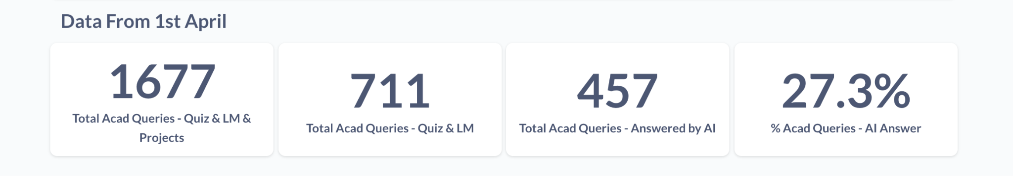

- For Quiz & Learning Materials - We auto answer now using a non-agentic model as of now. After project queries, we will enhance this too so all the acads queries are covered.
- Next step - We will increase the accuracy of Quiz & LM from 44% to 90%+

Milestone 2

Integrate one single GLAIDE (support query system) which has context of all the queries the learners has asked instead of multiple isolated system which we have

- Queries which the learners ask will be answered by a single system which has context of all the queries the learner asked anywhere during their learner journey
- Current system - Queries which the learner asked in Video GLAIDE would not be available in Support queries

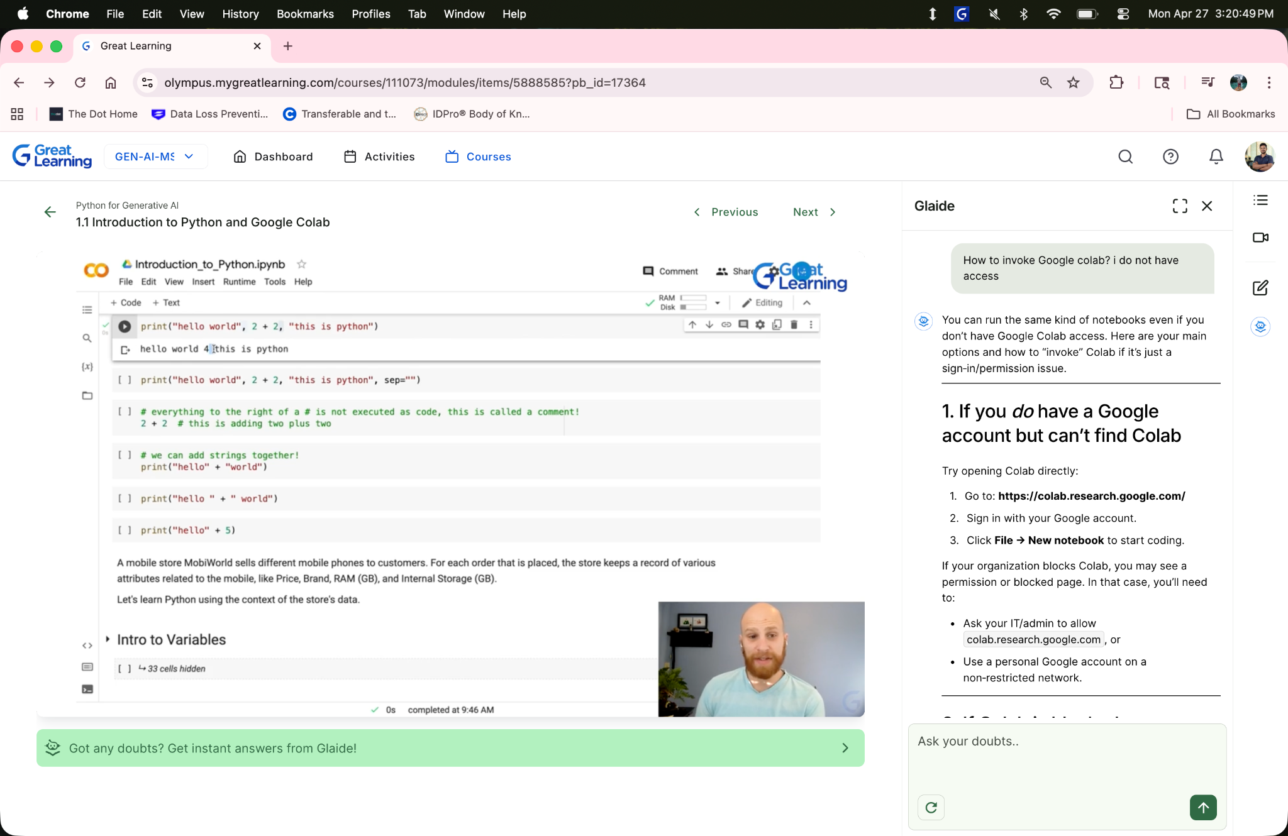

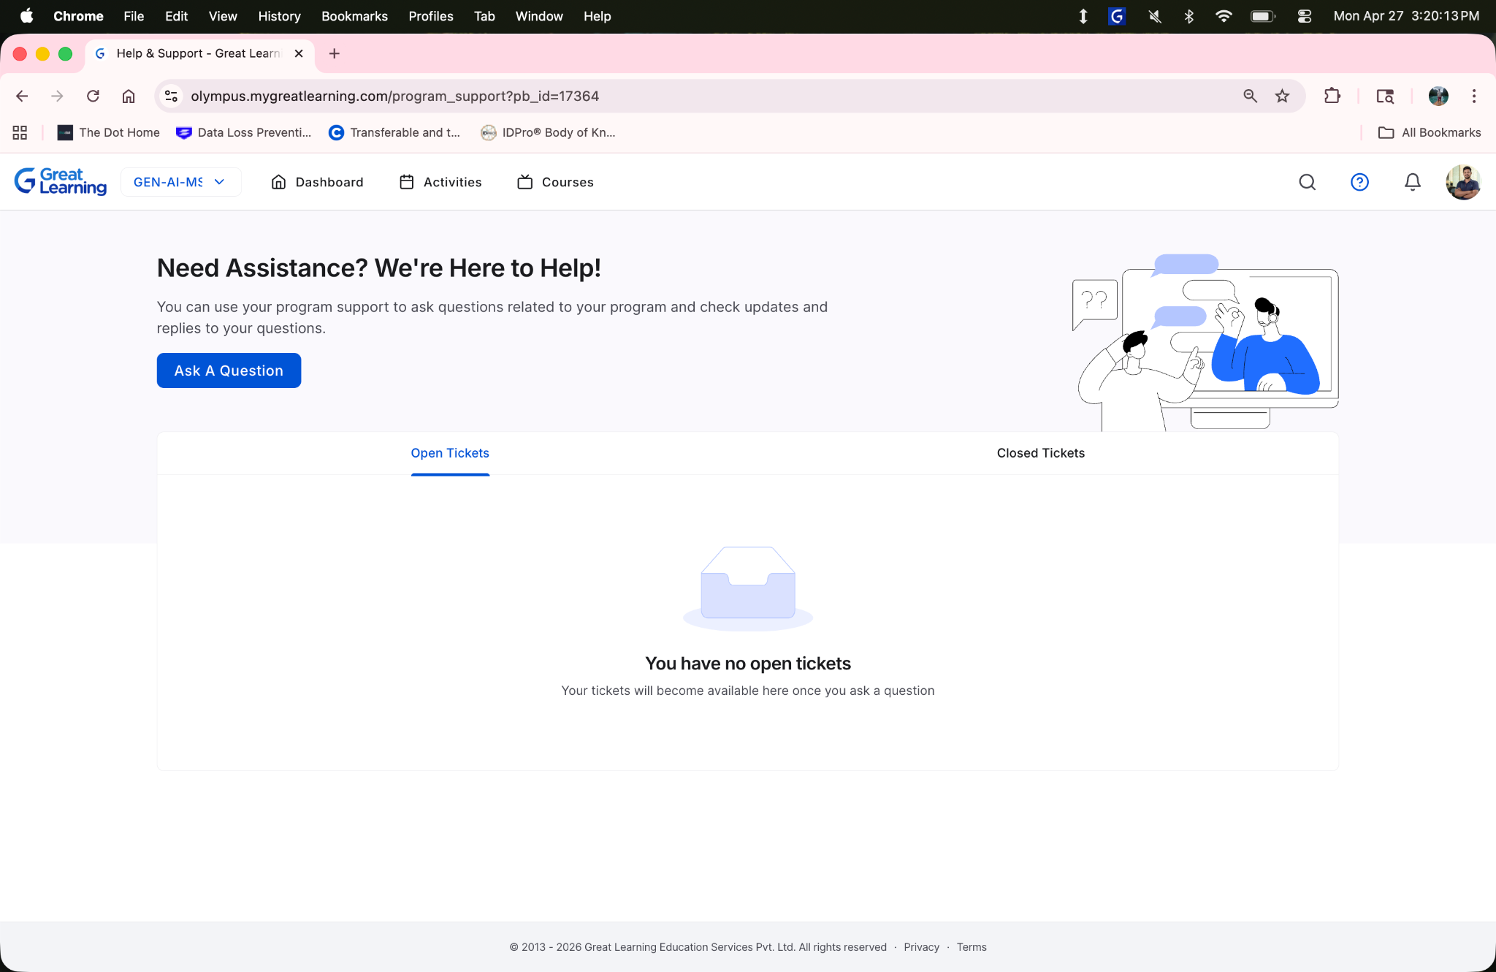

2 types of tools -

- Read Only -
- Write -

Read Only - We can simulate using any live SQ which we have in our system right now. Here, we won’t take actions/ change the state

Write - Whitelisted only for test programs (where will take action)

- Milestone scenarios
- Critical to have replayable scenario so that we can have test bed

Any queries related to the below categories should be handled by our internal teams

- Fee Related Queries
- Queries related to Careers
- Queries related to updating the attendance

Timelines

S.No | Task | Status | Timeline | Week
1 | Optimizing the agent for answering program office queries (Category - Fee Related) | In Progress | June 4 to June 11 | Week 6
2 | Collect knowledge base from operations team | In Progress | June 4 to June 11 | Week 6
3 | Optimizing the agent for answering Quiz & Learning Materials | Completed | May 27 to June 3 | Week 5
4 | Complete the final testing of Agentic model (projects) & start working on optimizing the agents for answering Quiz & Learning materials | Completed | May 21 to May 28 | Week 4
5 | Refine the agentic model - prompt & tools to answer one category of Academic queries from learners (Projects) | Completed | May 14 to May 21 | Week 3
6 | AI Mentor Playground is ready & available in staging now. Testing the functionalities & push the model to production | Completed | May 6 to May 13 | Week 2
7 | Developing an internal testing platform (AI Mentor Playground) to enable teams to evaluate agent responses at scale. | Completed | Apr 29 to May 6 | Week 1
8 | Creating a robust, representative test bed based on historical learner queries. | Completed | Apr 29 to May 6
9 | Analyzed 100K+ learner support queries across various channels to identify ~60 key categories, which now serve as the foundation for evaluating response quality. | Completed | Apr 22 to Apr 29 | Week 0
10 | Built ~75 AI agentic tools to address these query categories. | Completed | Apr 22 to Apr 29

Milestone 1 (1 month) - May 2026
Focus: Automate resolution of Academic Operations support queries, enabling the team to shift focus to higher-value work.

Milestone 2 (1 month) - June 2026
Focus: With the knowledge & expertise gained from Acad Ops support tickets, our agent should answer Program Office support tickets raised by our learners.

S.No | Detailed plan | Weeks | Dates
1 | Developing an internal testing platform (AI Mentor Playground) to enable teams to evaluate agent responses at scale. | Week 1 | Start of May
2 | AI Mentor Playground to be deployed to production | Week 2
3 | Test & Refine agent for answering Academic queries (Projects Only) | Week 3
4 | Test & Refine agent for answering Academic queries (Quiz & Learning Materials Only) | Week 4
5 | Provide the agent to AcadOps team for broader testing across all of our data programs | Will happen in parallel | End of May

Milestone 3 (1 month) - July 2026
Focus: Take the agentic platform live in front of all of our learners for all of our data programs.

9. How is it better compared to the older model?

Data for the older model -

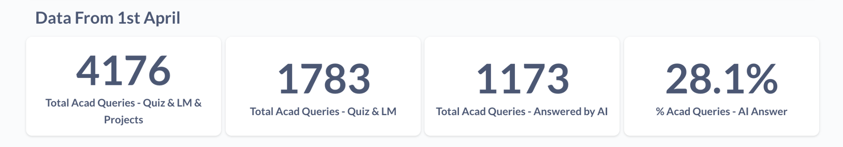

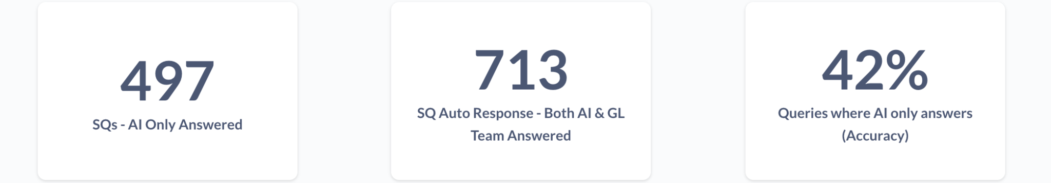

In total,

- % of Acads Query Coverage ~ 28%
- AI only Resolution ~ 42% (means 58% coming to the human)

Compared to the older/currently live model, the agentic model can -

- Gather context from the FAQs provided by the Academic & Operations team (uses a RAG approach to gather context dynamically)
- Can go through the learning content hosted within Olympus
- Conversational - will be able to chat & get additional context from the learners
- Websearch - can search on the web, depending on the nature of the query asked by the learner
- Take actions - Extend assessments (current policy/logic retained)

Projects -

S.No | Type Of Query Being Asked | Description | Support Query ID | What does the agent do? | Mix
1 | Stuck with code | Getting an error in .ipynb or unable to proceed forward | 720063 | LLM Knowledge | 30%
2 | Technical Query inside a project | Unable to convert the file to .html | 720112, 719152, 723888 | Searches in GL Learning system -> FAQ docs -> Websearch
3 | Lab Related Issues - | Unable to login, How to download lab in my local etc. | 720546, 719770 | Searches in GL Learning system -> FAQ docs -> Websearch | 30%
4 | Nocode Projects | KNIME issues, n8n lab issues, Azure lab issues | 720261 | Searches in GL Learning system -> FAQ docs -> Websearch
5 | Explanation of a guideline, rubric specified in a project | Should I take approach A vs B? | 720112 | Learning system + LLM Knowledge | < 10%
6 | Re evaluation request | Learner wants reevaluation from GL team | 720306 | Routes to GL team | 20%
7 | Unable to access the file | Learner unable to access the file as it is not published, authorization error etc. | 715346 | Searches in GL learning system | < 5 %

Quiz & Learning Material

Quiz -

S.No | Type Of Query Being Asked | Description | Support Query ID | What does the agent do? | Mix
1 | Mark disputes and learner has to be provided marks | The learner argues their answer is correct. Depending on the context, we provide/ not provide marks | 724337, 724225 | Routes to GL team | 40%
2 | Explanation for the correct answer | Learner wants to know why certain answer was correct | 724047 | Searches in GL Learning system + LLM Knowledge | 20%
3 | Stuck with code in code eval | Learner wants to know why code is not working in code eval, why he got x marks etc. | 724597, 724190 | LLM Knowledge + Searches in GL Learning system (when required) | 40%

Learning Material

S.No | Type Of Query Being Asked | Description | Support Query ID | What does the agent do? | Mix
1 | Lab related technical doubts - how to get key, create a resource | Login issues in lab, lab not showing up | 724449, 724244 | Searches in GL Learning system + FAQ docs | 60%
2 | Not able to find/download the file | File not published, learner unable to find the file which was used in the mentorship session etc. | 724485 | Searches in GL Learning system | 20%
3 | Query in the faculty video where some explanation was incorrect/ dicey | Faculty explanation was incorrect/ more details required, text is incorrect in the learning document | 724593, 724155 | Searches in GL Learning system + transcripts from the video | 20%

10. Important Documents Link

Test Cases - TestBed - Support Queries Only

Labs Documents - Acad Ops - Labs + FAQs Info

Program FAQs - Master FAQ Document - Delivery Operations

11. Miscellaneous

- Send the URL
- Lightpanda - for step-by-step screenshots

- Find out the total queries - classify them
- Reach 50%, but for extension queries

